**MINI PROJECT REPORT**

**ON**

***Messify***

**BY**

**Group Number: 6**

**Team List**

**Samar Devendre Vispute**

**Vinay Purshottam Purohit**

**SAVITRIBAI PHULE PUNE UNIVERSITY**

**MASTER IN COMPUTER APPLICATION**

**MAHARASHTRA EDUCATION SOCIETY’s**

**INSTITUTE OF MANAGEMENT AND CAREER COURSES**

**(IMCC), PUNE-411038**

**2023-24**

**Ref. No. MES IMCC / 399-A/ 2023 – 24 Date: 28/03/2024**

*CERTIFICATE*

This is to certify that the Project Report entitled **“Messify*”*** is prepared by **Samar Vispute And Vinay Purohit** a students of **MCA (Semester 2)** Program for the Academic Year 2023-24 at M.E. Society's Institute of Management & Career Courses (IMCC), Pune - 411 038. MCA Program is affiliated to Savitribai Phule Pune University.

To the best of our knowledge, this is original study done by the said students and important sources used by them have been duly acknowledged in this report.

The report is submitted in partial fulfillment of MCA Program for the Academic Year 2023-24 as per the rules & prescribed guidelines of Savitribai Phule Pune University.

## Dr. Ravikant Zirmite



Head, Dept of MCA

MES IMCC

## Dr. Santosh Deshpande

Director

MES IMCC

|  |  |  |
| --- | --- | --- |
| **Sr. No.** | **Detail** | **Page NO** |
| **1** | **Project Scope** |  |
| **2** | **Use case diagram** |  |
| **3** | **Class Diagram** |  |
| **4** | **Database design** |  |
| **5** | **User Interfaces** |  |

**Index**

**Project Scope**

**Messify** is the application which helps you to find nearby mess with the help of your current location . It uses location to Overview:

Messify is an intuitive application designed to help users discover nearby messes effortlessly. It utilizes GPS technology to provide users with a convenient way to find dining options based on their current location or a custom location.

**Key Features:**

**Location-Based Search:**

Users can easily find nearby messes by enabling location services on their devices.

Messes are displayed on a map interface, sorted by proximity to the user's current location for easy access.

**Custom Location Setting:**

Users have the option to set a custom location, allowing them to explore messes in specific areas.

**Detailed Mess Profiles:**

Each mess listing includes essential details such as menu offerings, operating hours, contact information, and user ratings.

**Customizable Filters:**

Messify offers customizable filters based on preferences such as cuisine type, price range, ratings, and special offers.

**Feedback System:**

Users can leave reviews and ratings for messes they visit, helping others make informed dining decisions.

**Online Membership and Payment:**

Users can subscribe to memberships for specific messes, supports seamless online payment directly through the application.

**Integration with Google Maps:**

Messify seamlessly integrates with Google Maps for easy navigation to chosen messes.

**3: UseCase Diagram**

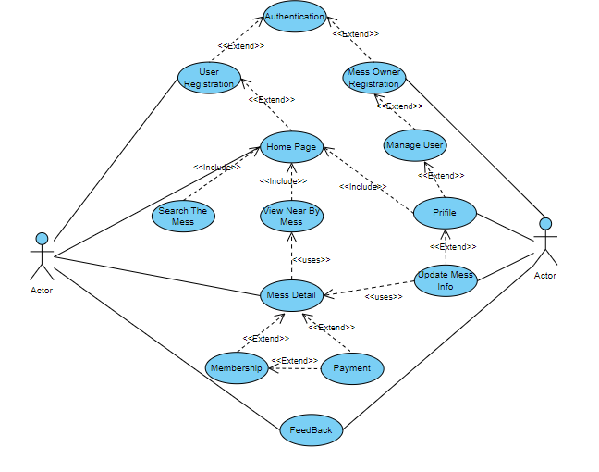

**4: Class Diagram**

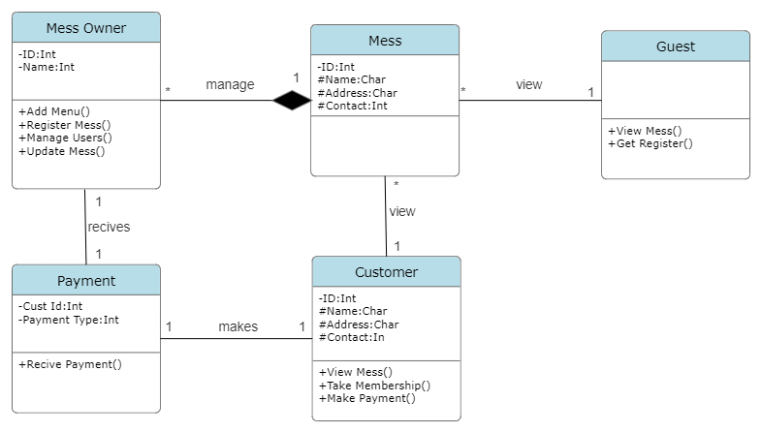

**5: Database Design**

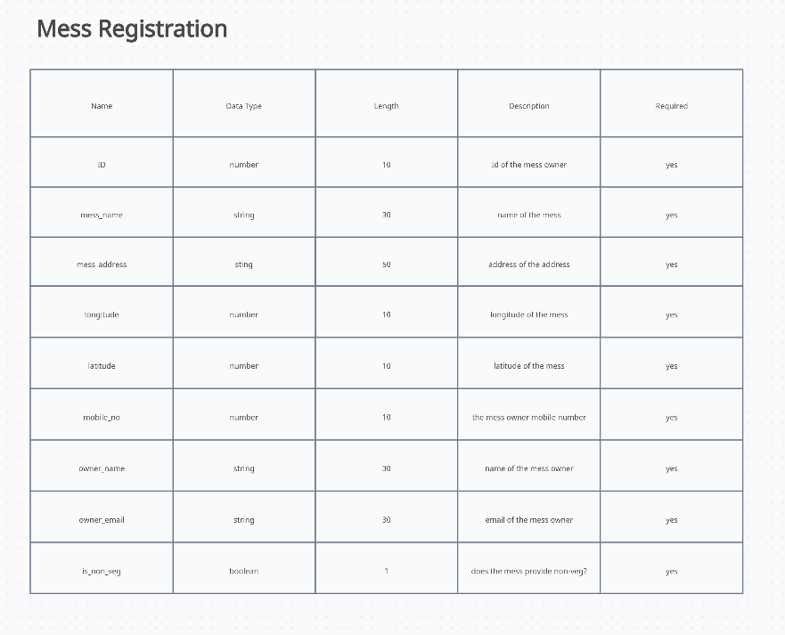

User Registration

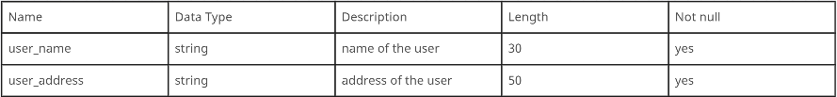

**6: List of User Interfaces and its description/purpose**

**1. Login Page:**

**Purpose:** Allows users to log in or register.

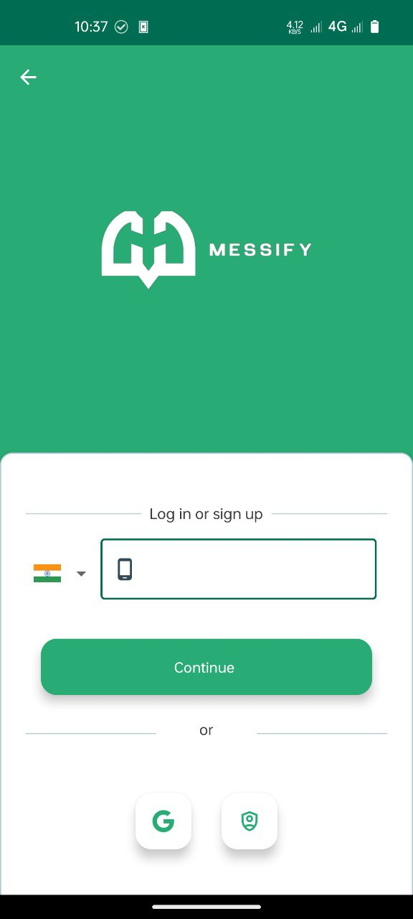

**Features:**

- Input field for mobile number.

- OTP verification after mobile number input.

- Registration option for new users.

- Firebase authentication for secure login.

**2. Admin Panel:**

**Purpose:** Allows admin to see registered users, anonymous users, and mess owners.

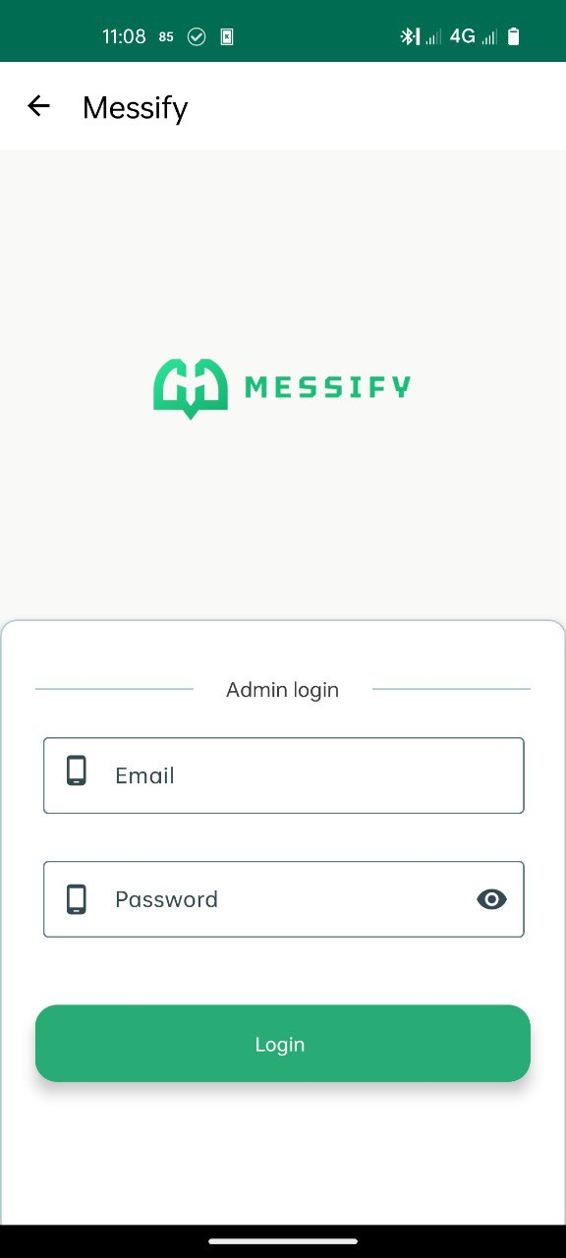 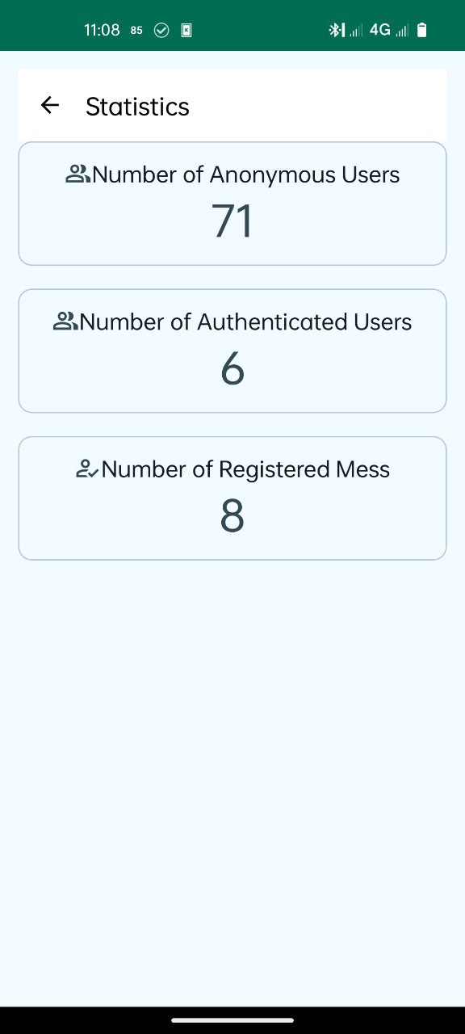

**Features:**

- Login for admin authentication.

- View all registered users.

- View anonymous users.

- View mess owners.

**3. Mess Registration Page:**

**Purpose:** Enables users to register by providing necessary information.

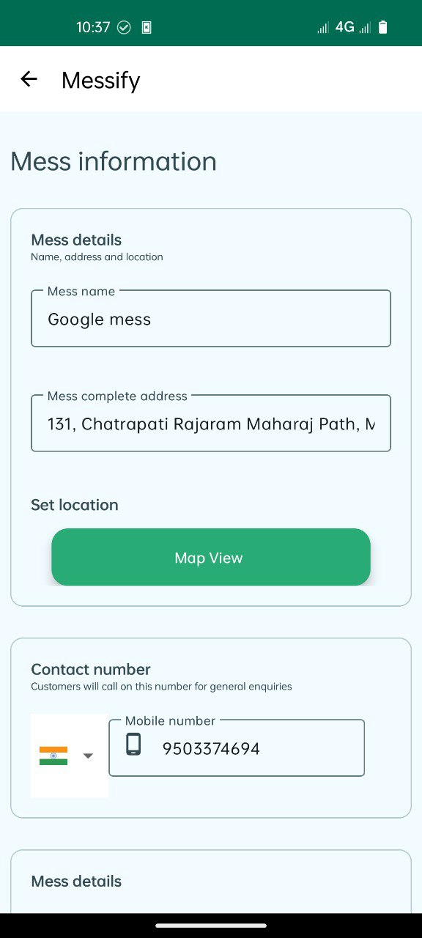

**Features:**

- Input fields for mess name, address, price, type, mobile no, location, time etc.

- Firebase integration to store mess data.

- Validation to ensure the completeness of the registration information.

**4. Home Page:**

**Purpose:** Serves as the main landing page with an overview of available messes**.**

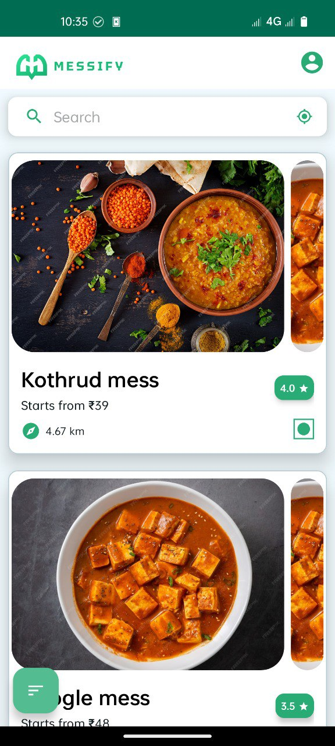

**Features:**

- Display a list of messes around the user.

- Sort messes by the shortest distance.

- Search bar for users to find a specific mess.

**5. Mess Detail Page:**

**Purpose:** Provides detailed information about a specific mess.

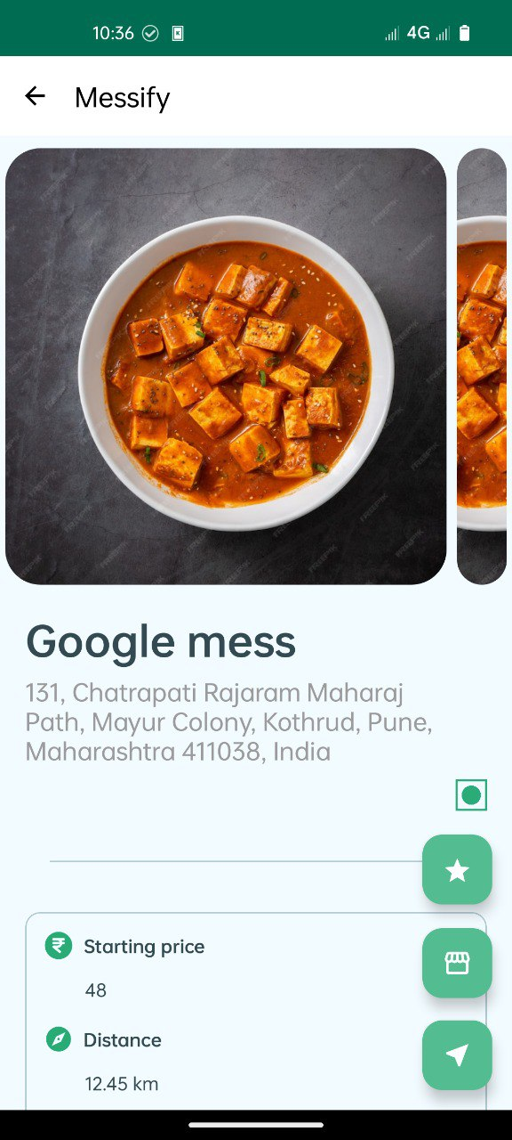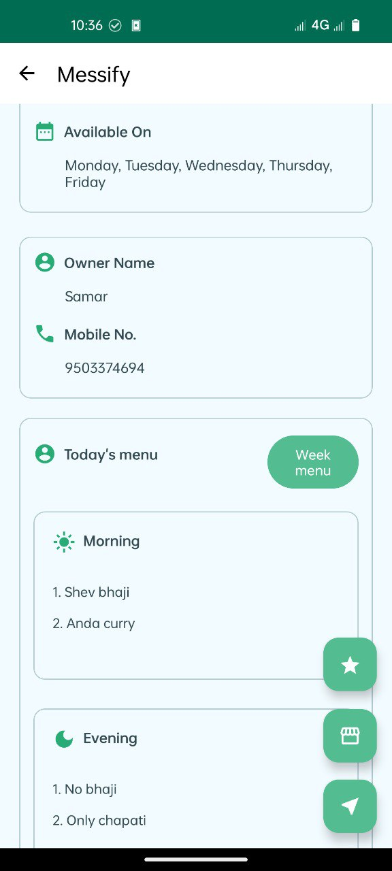

**Features:**

- Display mess owner details.

- Show images of the mess and its food.

- Present the mess location and timings.

- Integration with Google Maps for directions.

**6. Profile Page:**

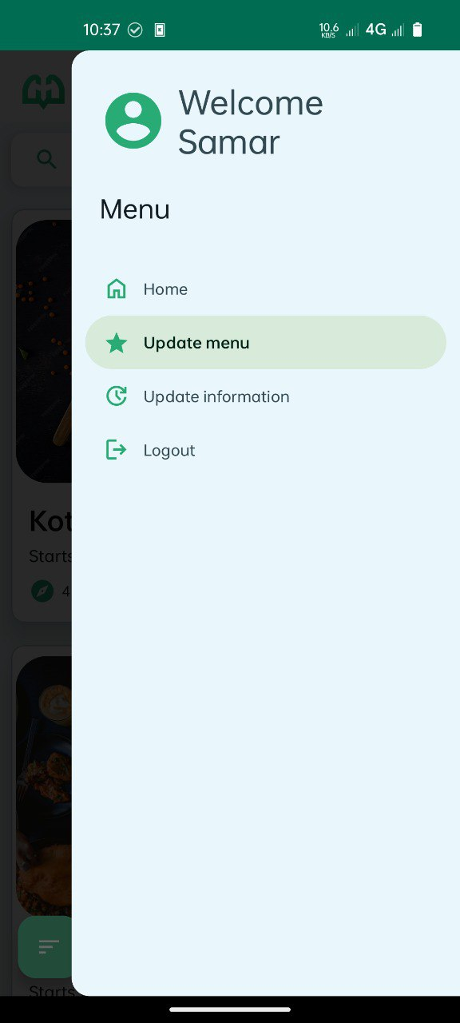

**Purpose:** Allows users or admins to manage their profiles.

**Features:**

- View and edit personal details (e.g. name, address).

- Change profile picture.

- Logout functionality.

**7. Sort:**

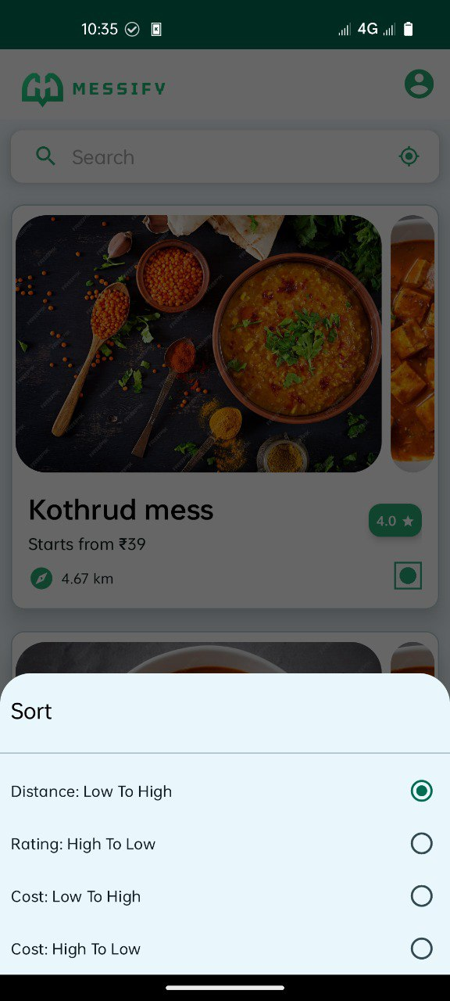

**Purpose:** Allows users to sort mess according to distance, rating & price.

**Features:**

- 1:-Sort Mess According to distance

2:-Sort Mess According to Rating

3:-Sort Mess According to Price (low to high or high to low)

**8. Map View:**

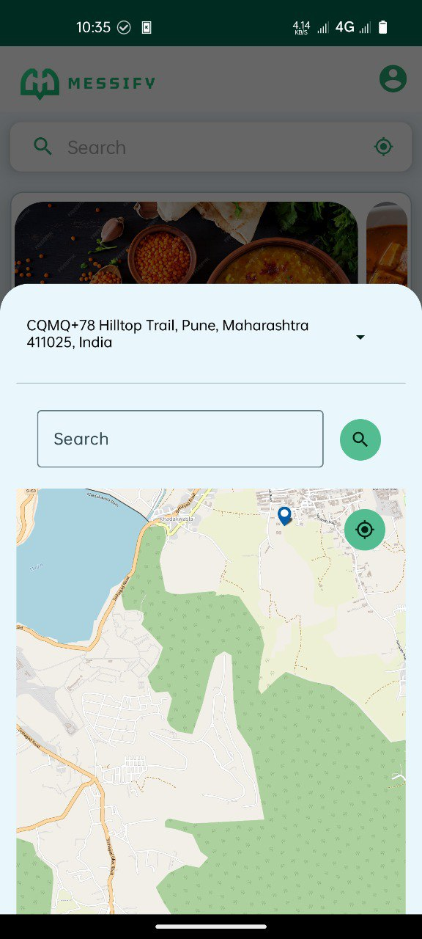

**Purpose:** Allows users to Search a mess at any location by using the map

**Features:**

User can pin any location they

want to search a mess near by

**9. Rating:**

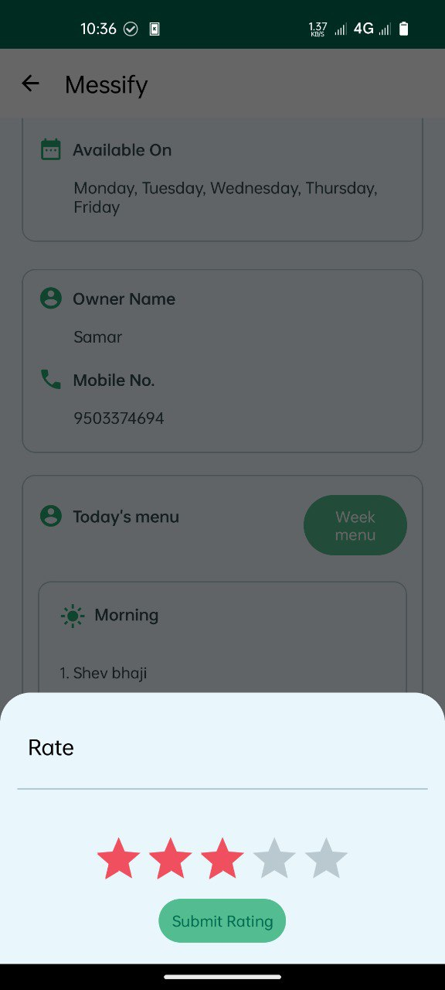

**Purpose:** Allows users to Rate a Mess and also

show how much is the rating of a mess

**10. Membership:**

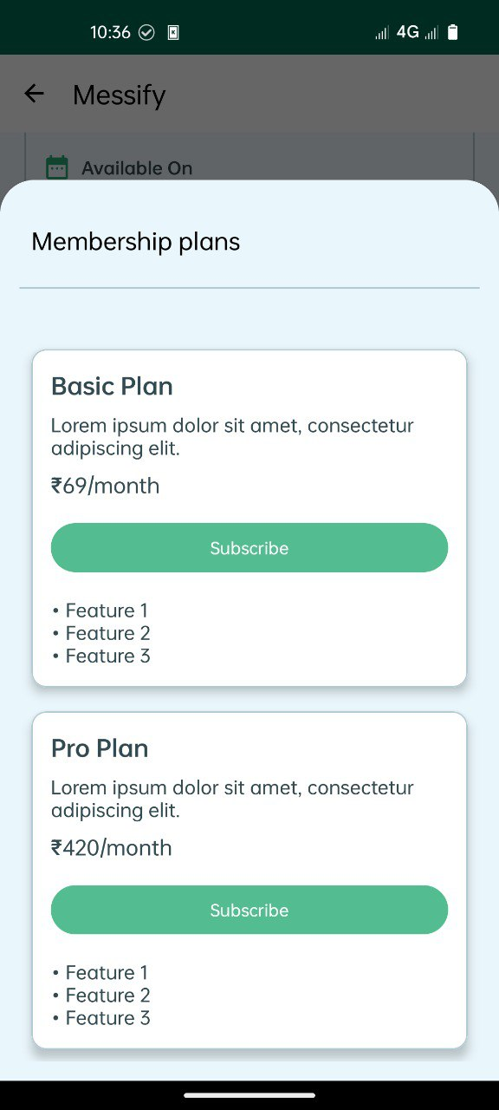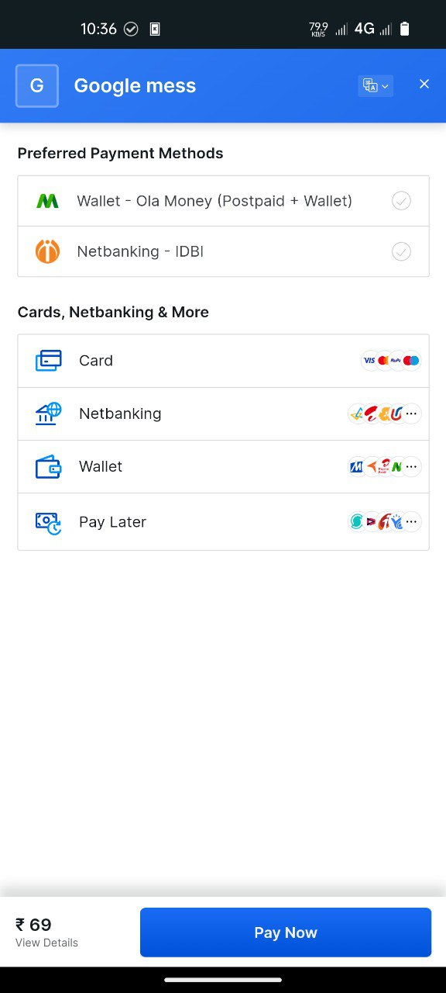

**Purpose:** Allows users to take membership of a mess

**Features:**

User can buy the membership plans

for a mess form messify app